**2.F. San Kei En Project**

**(Japanese Friendship Garden Haiku Hunt)**

Deployment of location-based apps in outdoor spaces can be difficult, especially in gardens with varied terrain that can obstruct Wi-Fi signals. Additionally, signage alerting users to these services can be problematic because it interferes with the aesthetic goals of Asian gardens. This project created the first outdoor, location-aware mobile app using the Place-Sticker technology developed by Information Services International-Dentsu LTD, Tokyo, Japan (ISID). It continues the productive collaboration between Balboa Park Online Collaborative (BPOC), the National Institute of Information and Communications Technology (NICT) in Japan, and the Pacific Rim Undergraduate Experience (PRIME) program at University of California, San Diego (UCSD). Two PRIME students from 2012, Michael Yao and Scott Mo, developed the first iteration of this application, which was subsequently refined and launched at Balboa Park’s Timken Museum of Art in April 2013. The Timken was the first museum in the United States to feature an Android-based mobile gallery guide using this type of experimental location-based technology. The project was highlighted in The Center for the Future of Museums (CFM) dispatches, a nationally recognized forum that assists museums in shaping a better tomorrow by exploring cultural, political, and economic challenges.

PRIME 2013 student Jesus Rios extended this Android-based application by developing an interactive game that would lead visitors through the San Diego Japanese Friendship Garden (JFG) while providing additional metadata content not readily available to the public. Haikus, crowd-sourced through an online contest, provided the “riddles” visitors had to solve to find specific locations. Visitors to the garden begin by downloading the app to their mobile device and are presented with abstract Sumi-e drawings representing the ten locations featured in the app. The visitor taps on an image and a haiku appears with a detail of the Sumi-e drawing, as well as sound clues (when appropriate). The visitor must solve the clues and haiku to find the location. A Place-Sticker device is assigned to each garden feature and will send low-power radio signals to visitors’ mobile devices signaling their location. When the visitor finds the particular garden feature (e.g. koi pond, cherry tree grove, dry waterfall, etc.) described in the haiku, supplementary information (text, audio, or video) is displayed on their device. Once the visitor leaves this location, the tour will be updated and the visitor can proceed to the next haiku.

This prototype system was presented at The Lab in the Knowledge Capital (Umeda, Osaka, Japan). This is a large intellectual entertainment space where people are connected and where the future is conceived. Demonstrating in this space allowed us to obtain initial feedback from users on the functionality of the application. Based on this feedback, the application is undergoing minor adjustments and will be deployed at JFG in Fall 2013. The public launch will also include a new solar powered prorotype version of the Place-Sticker device. This project will be the first successful development and deployment of this type of technology in an outdoor environment.

*Participants: PRIME 2013 Student: Jesus Rios; NICT: Shinji Shimojo; BPOC: Vivian Kung Haga, Wesley Hsu (PRIME 2011); Information Services International-Dentsu (ISID): Kazuhiro Toda; Ritsumeikan University: Nobuhiko Nishio; UCSD: Jason H. Haga*

*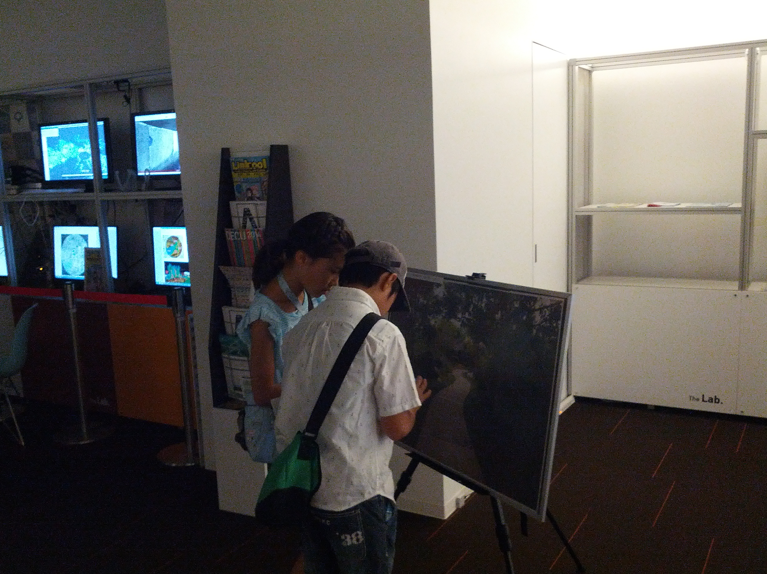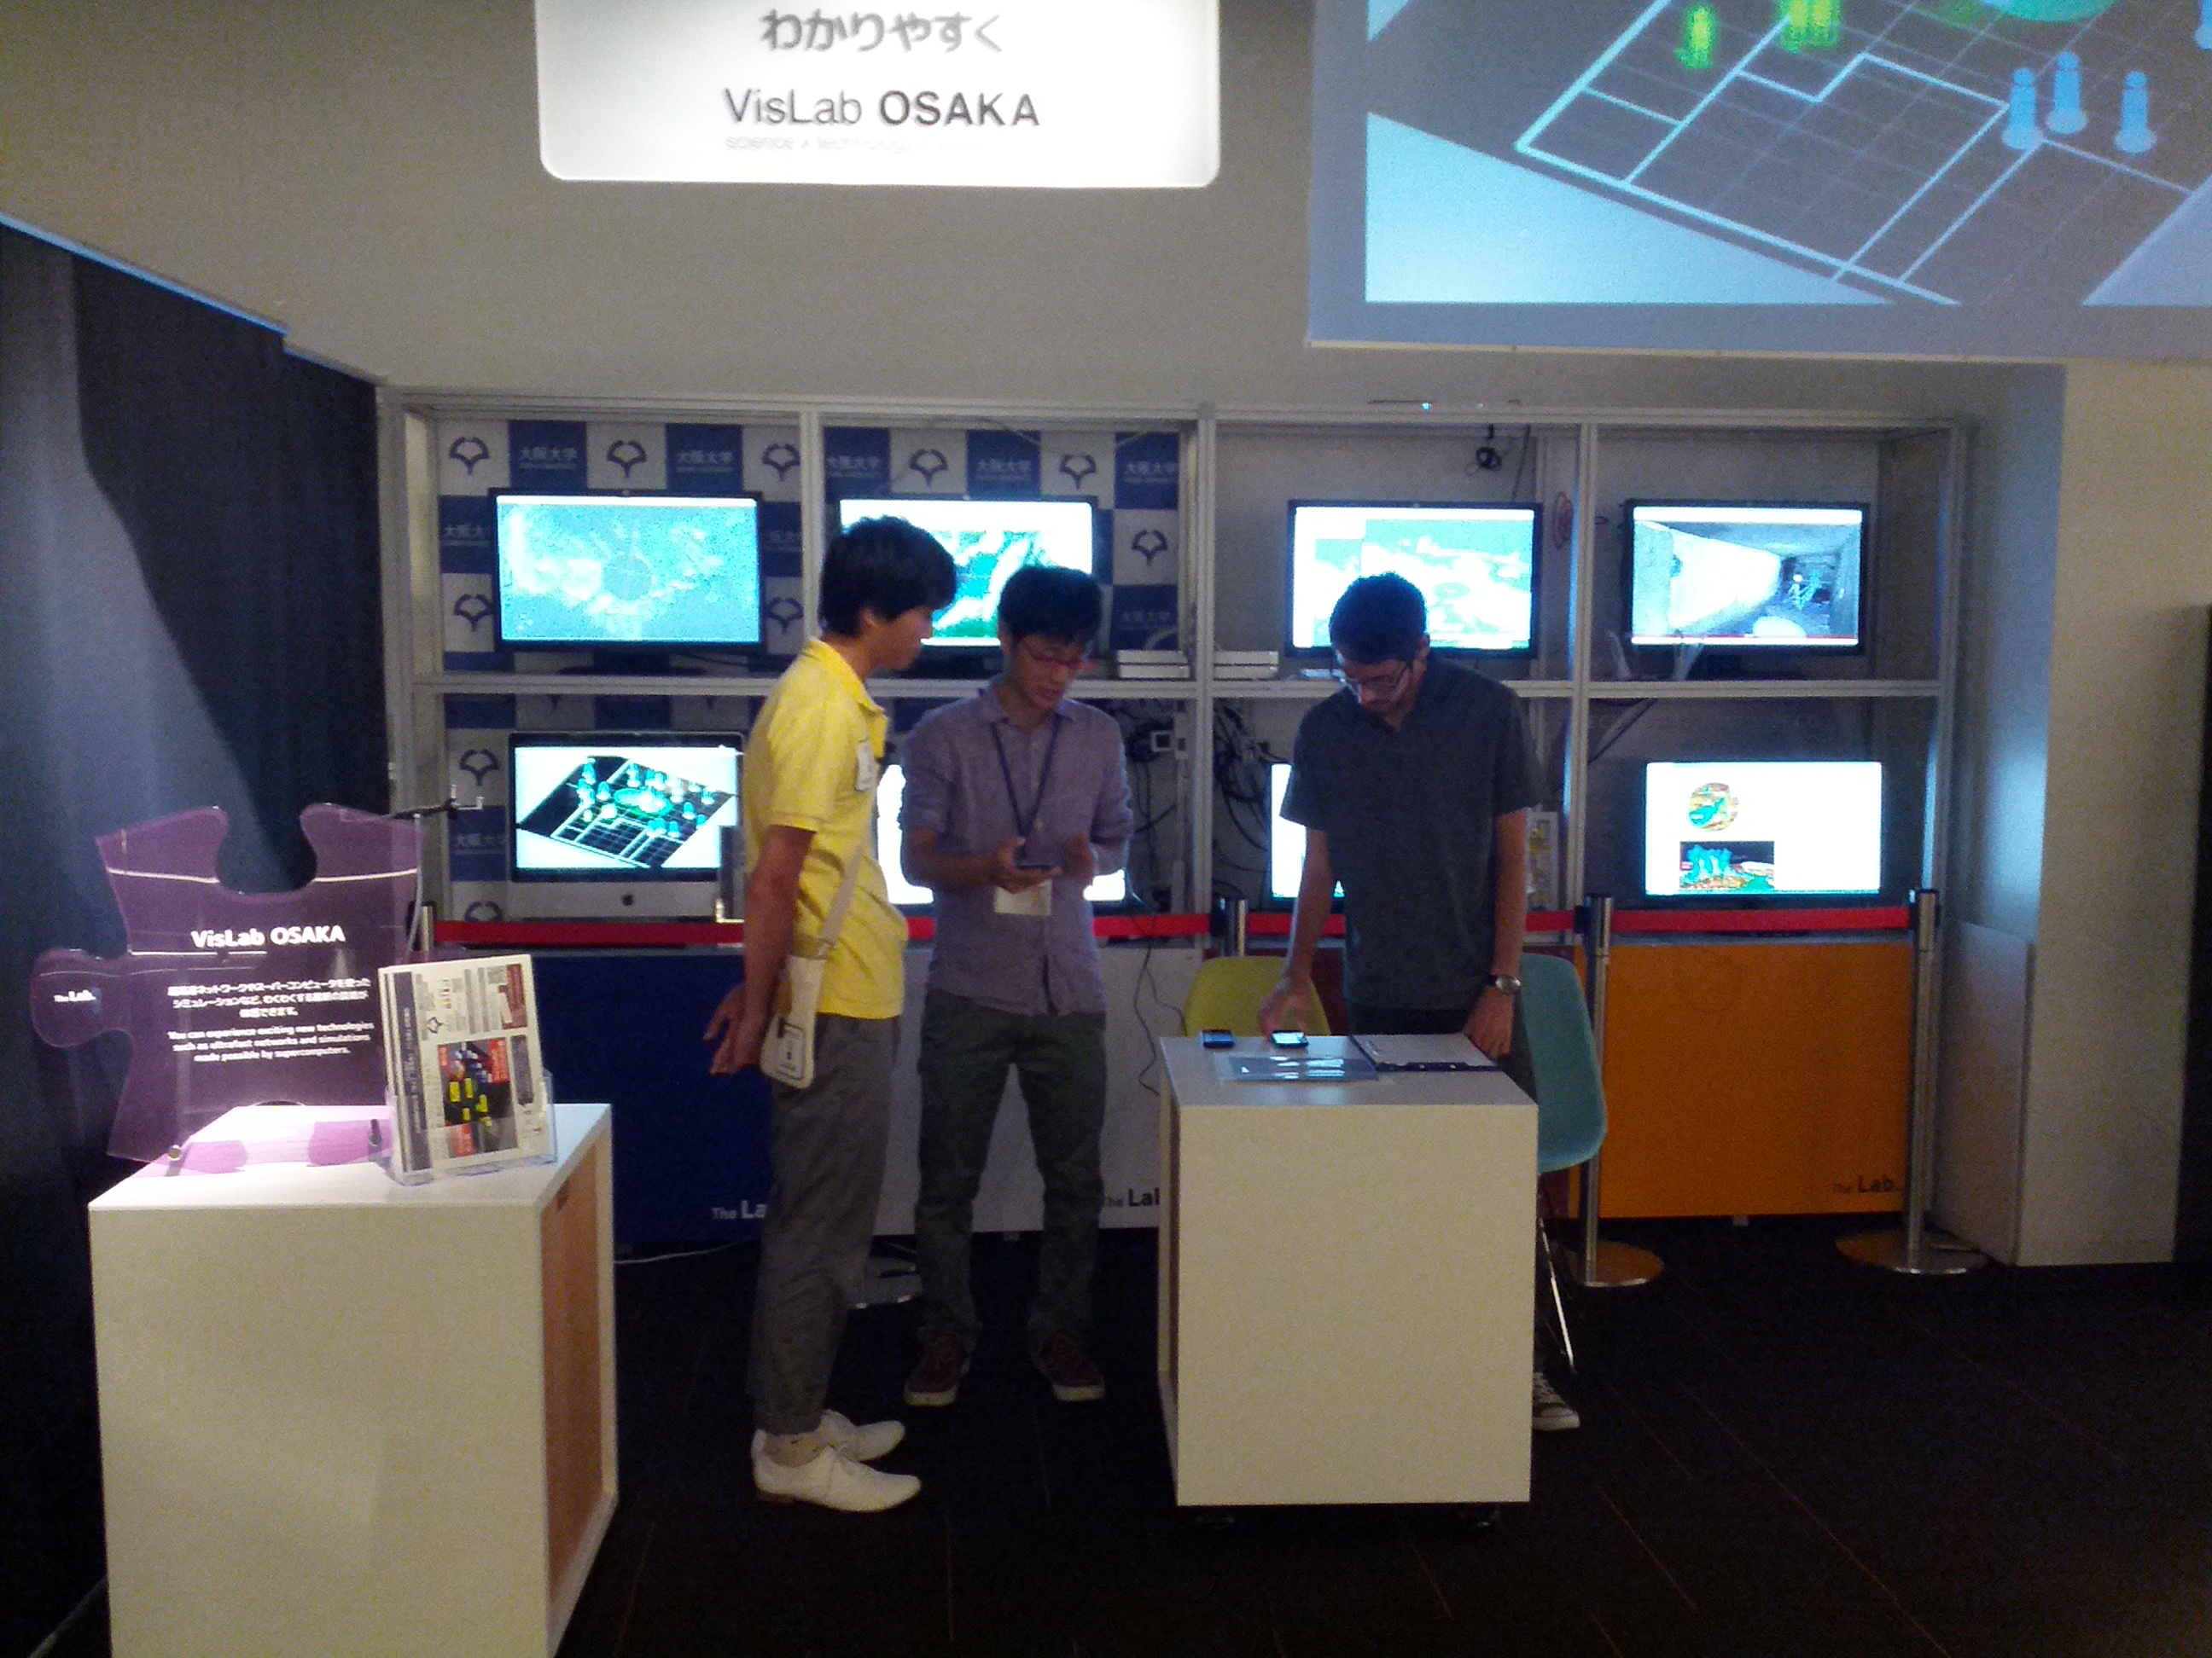 Fig. Demonstration in the Lab.*

*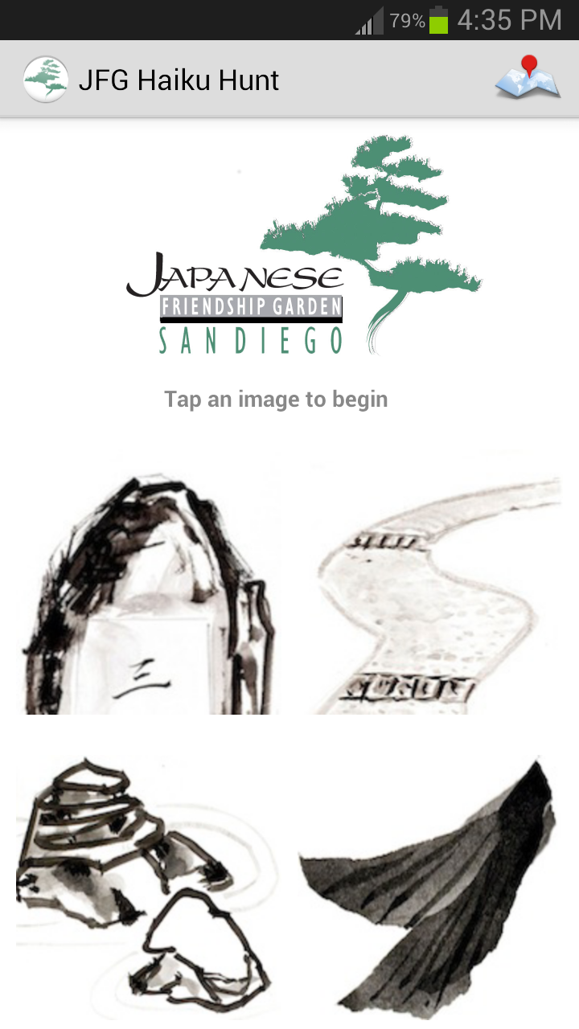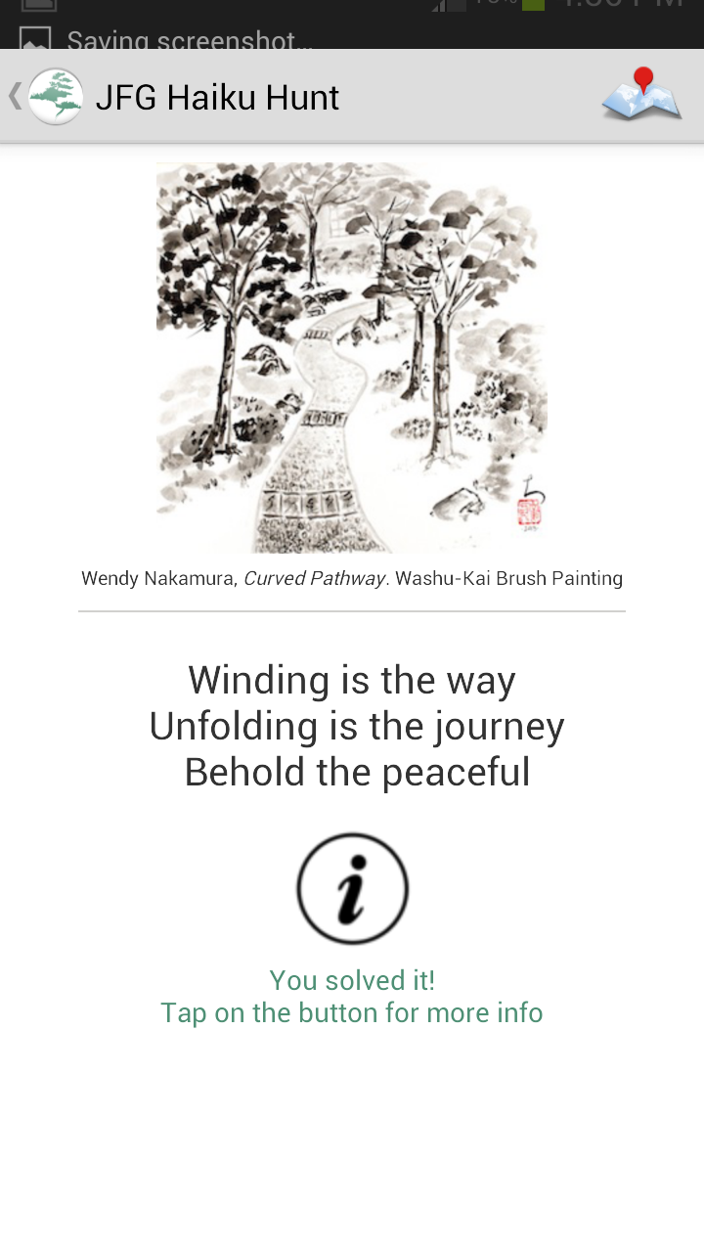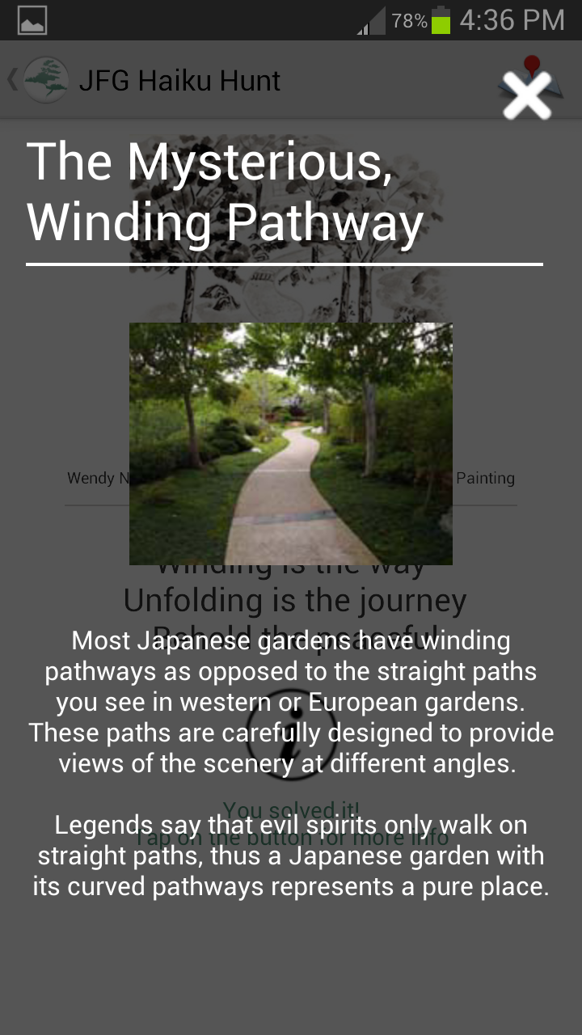 Screenshots from JFG android app: main page, solved winding pathway screen, and detailed information screen.*